Stakeholders of (De)-Radicalization in Poland
  - Poland/D3.1 Country Report
  - April 2021

  - Maria Moulin-Stożek – Jan Długosz University in Częstochowa
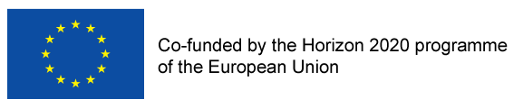
Horizon 2020
De-Radicalisation in Europe and Beyond: Detect, Resolve, Re-integrate
959198

© Maria Moulin-Stożek
Reference: D.RAD [D3.1].
This research was conducted under the Horizon 2020 project ‘De-Radicalisation in Europe and Beyond: Detect, Resolve, Re-integrate’ (959198).
The sole responsibility of this publication lies with the author. The European Union is not responsible for any use that may be made of the information contained therein.
Any enquiries regarding this publication should be sent to m.moulin-stozek@ujd.czest.pl.
TO CITE USE: Moulin-Stozek M., (2021) Stakeholders of (De)-Radicalization in Poland. D3.1 Country Report. Horizon 2020 project ‘De-Radicalisation in Europe and Beyond: Detect, Resolve, Re-integrate’ (959198).
Table of Contents
List of Abbreviations 4
About the Project 5
Executive Summary/Abstract 6
1. Introduction 7
2. Contextual background 8
3. Structure of radicalization 11
3.1. Political violence in Poland 11
3.2. Perception of the violent threat by the political elite 14
3.3. Perception of the violent threat by the general public 15
4. Stakeholders and channels of radicalization 16
4.1. Collective agents responsible for violent political attacks in Poland 16
4.2. Policing as a channel of radicalization 19
5. Stakeholders and channels of de-radicalization 20
6. Conclusions 23
Appendices 24
Appendix 1: Main (de-)radicalization events in Poland since 2001 24
Appendix 2. Political discourse about radicalization in Poland 27
Appendix 3. Networks of connection of the main agents of radicalization in Poland 33
Appendix 4. Main de-radicalization programs in Poland 40
References and Sources 43

List of Abbreviations

ABW Internal Security Agency (‘Agencja Bezpieczeństwa Wewnętrznego’)
AW Foreign Intelligence Agency (‘Agencja Wywiadu’)
CBOS Public Opinion Research Center (‘Centrum Badania Opinii Publicznej’)
CPT ABW Terrorism Prevention Centre of Excellence (‘Centrum Prewencji Terrorystycznej ABW’)
EU European Union
kk Polish Criminal Law Code (Ustawa z dnia 6 czerwca 1997 r. Kodeks karny (Dz. U. 1997 Nr 88, poz. 553 ze zmianami))
NATO North Atlantic Treaty Organization

About the Project
D.Rad is a comparative study of radicalisation and polarisation in Europe and beyond. It aims to identify the actors, networks, and wider social contexts driving radicalisation, particularly among young people in urban and peri-urban areas. D.Rad conceptualises this through the I-GAP spectrum (injustice-grievance-alienation-polarisation) with the goal of moving towards measurable evaluations of de-radicalisation programmes. Our intention is to identify the building blocks of radicalisation, which include a sense of being victimised; a sense of being thwarted or lacking agency in established legal and political structures; and coming under the influence of “us vs them” identity formulations.
D.Rad benefits from an exceptional breadth of backgrounds. The project spans national contexts including the UK, France, Italy, Germany, Poland, Hungary, Finland, Slovenia, Bosnia, Serbia, Kosovo, Israel, Iraq, Jordan, Turkey, Georgia, Austria, and several minority nationalisms. It bridges academic disciplines ranging from political science and cultural studies to social psychology and artificial intelligence. Dissemination methods include D.Rad labs, D.Rad hubs, policy papers, academic workshops, visual outputs and digital galleries. As such, D.Rad establishes a rigorous foundation to test practical interventions geared to prevention, inclusion and de-radicalisation.
With the possibility of capturing the trajectories of seventeen nations and several minority nations, the project will provide a unique evidence base for the comparative analysis of law and policy as nation states adapt to new security challenges. The process of mapping these varieties and their link to national contexts will be crucial in uncovering strengths and weaknesses in existing interventions. Furthermore, D.Rad accounts for the problem that processes of radicalisation often occur in circumstances that escape the control and scrutiny of traditional national frameworks of justice. The participation of AI professionals in modelling, analysing and devising solutions to online radicalisation will be central to the project’s aims.

Executive Summary
Poland continues to be a country with a low level of terrorist threat. However, because of its geographical location, strategic relationships with other countries and international organizations, as well as internal matters, terrorist attacks cannot be ruled out.
Political violence in Poland is outlined using data provided by the Internal Security Agency and the police, as well as hate crime statistics from the Ministry of Justice and the National Prosecutorial Office. Bias motivation is gathered in an electronic database during collecting data on the circumstances of the crime and motivation of the perpetrator. The Internal Security Agency report showed that between 2015-2019 there were investigations into right-wing, left-wing and jihadist terrorism. Ethnonationalist/separatist political violence is not an issue in Poland. Last mention of separatist potential threat was in 2000 report and it was related to the region of Silesia. There is also evidence of strong but decreasing political polarisation on violent threat and law on counterterrorism.
One Polish NGO works exclusively on de-radicalization, while other projects tend to teach about multiculturalism, tolerance, interfaith dialogue, mastering emotions, controlling aggression and ‘positive patriotism’. They are carried out by the government on national level and locally, or by different associations, foundations and religious organizations. Some programs are directed specifically towards football fans, who are particularly prone to right-wing radicalization.
Among the most important challenges this report identified lack of independent criminological research into the number of (unreported) hate-motivated crimes against minorities, problems related to transparency and independent supervision of the Internal Security Agency, and legal evaluation of the relationship between hate speech and freedom of speech in the Polish context to properly challenge xenophobic and racist narratives.

Introduction
The purpose of this report is to map stakeholders or radicalization and deradicalization in Poland. Although the analysis covers the years 2001- 2021, it also refers years prior to 2001 in situations when it is important to understand the specific context.
This country report is prepared within Work Package 3 ‘Mapping Stakeholders and Situations of Radicalization’ under the Horizon 2020 project D.Rad ‘De-Radicalization in Europe and Beyond: Detect, Resolve, and Re-Integrate’. The core objective of this report it is delineate the main radicalization agents and de-radicalization stakeholders in Poland. The report followed guidelines as outlined in Work Package 3 and it is composed of an introduction, a section on contextual background, next it describes structure of radicalization, stakeholders and channels of radicalization and finally, stakeholders and channels of de-radicalization. The last part of the report are the conclusions emphasizing the most important findings and policy recommendations.
This report uses Work Package 3 definitions, where radicalization is understood as ‘a process involving the increasing rejection of established law, order, and politics and the active pursuit of alternatives, in the form of politically-driven violence or justification of violence,’ while de-radicalization is a ‘processes countering such rejection at individual (micro), organizational (meso), or societal (macro) levels resulting in a shift from violent to nonviolent strategies and tactics; de-radicalization might or might not be an outcome of de-radicalization programs’. Cases of radicalization have also been defined here after the Work Package 3 definitions. These are: ethnonationalist and separatist, jihadist, right-wing, and left-wing terrorisms.
Data used for this report consists of information requested from stakeholders, publicly available reports, documents, published by international and national public bodies, organizations, non-governmental organisations, as well as academic literature. Where necessary legal research was conducted to retrieve necessary information about laws.

2. Contextual background
Although Poland has some of the largest special services in Europe (Commissioner for Human Rights, 2019c), it is considered a country of low level of terrorism. However, as Poland actively participates in counterterrorist campaigns peace operations carried out by the European Union (EU) or North Atlantic Treaty Organization (NATO) retaliation actions or terrorist attacks cannot be ruled out (National Security Bureau, 2014). Polish national interests and strategic objectives in the field of security have to be seen within its geographical and historic context. This section looks at this context and other relevant information, however, it is limited only to the most relevant historical facts that have an influence on Polish radicalization as of contemporary Poland. It focuses on the most important developments in the last 20 years, but it also mentions earlier events, when it was necessary to understand the current radicalization context (see Appendix 1).
Poland, because of its geographical location (with its borders existing also as the EU border with non-EU countries) is a transit country, as well as for terrorist groups. It could be used as a logistic base for the preparation of attacks in other countries, especially in Western Europe. Potential targets include also Polish residents who are citizens of high-risk countries as well as Polish citizens and soldiers in high-risk countries. At present Polish national security policy is defined by its membership in the EU and NATO, relations with Russia and strategic presence of the USA. In 2003/2004, for example, the Internal Security Agency prevented a series of jihadist attacks planned in four Polish churches during Christmas celebrations, in which several thousand people could have died (Koziej, 2014). The attacks were planned as a retaliation for joining the 2003 US invasion of Iraq. Besides being an ally of the USA, active member of EU and NATO, Poland developed strategic relationship with the neighboring countries, especially with the Ukraine.
Since 1989 when Poland underwent major political, social, and economic transformation, new challenges have emerged. The opening of Poland increased global migration, but also cooperation in the field of national security to combat emerging international and asymmetric threats. Joining NATO in 1999 was an important pillar of Polish security policy. The activity of the Polish Military Representation to the NATO Military Committee revolves around military security of the Euro-Atlantic area, and includes exchange of information and intelligence data, military cooperation with NATO allies and partners, as well as international security institutions. Based on the NATO treaty, any external armed attack against one or more members is treated as an attack against all signatories to the agreement.
Polish national security is highly correlated with the situation in the other EU members so another important step for Poland was its accession to the European Union in 2004. Because of it, Poland benefits from policy transformations towards radicalization that take place in Europe. Next relevant moment was the accession of Poland and other new EU countries to the Schengen Agreement in December 2007, because it made it easier for foreign fighters to transit through Poland between EU and high-risk countries (Jałoszyński, 2008).
Another milestone for Polish national security was the Syrian war and the European migrant crisis 2014-2015 when the European Agenda on Migration of the European Commission proposed distributing 40,000 refugees between EU member states. This was brought up by political parties and informed some of the most intense political debates during presidential and parliamentary elections in 2015 (Foley, Gyollai, and Szalanska, forthcoming). It intensified discussions about state security in Poland, but also polarised Polish society. Eventually anti-refugee political discourse lead to the growth of negative attitudes towards Arab and African immigrants, Islamophobia and racism (Dudzińska and Kotnarowski, 2019; Górak-Sosnowska and Pachocka, 2019).
New approaches to Polish national security in cyberspace were developed after ‘Arab Spring’ that commenced in 2011, when protesters shut off from conventional ways, organized their activity through social portals. This exemplified that besides having a positive role in the process of democratization, online blogs and social networks might also impact national security systems.
Polish approach to radicalization has been shaped by important events that had an influence on counterterrorism such as: 9/11, but also attacks in Moscow (2002) Madrid (2004), Beslan (2004), Paris (2015), Barcelona (2017), London (2005, 2017) or Manchester (2017). These attacks shaped a perception that also Poland cannot be considered immune to terrorism. It became clear that Polish national security needs specialized mechanisms and structures that can successfully prevent terrorist attacks. This perception influenced a number of changes in the organization of national security in Poland and forms of joining in the global efforts to eradicate terrorism. For example, after bombings in Madrid the entire organization was thoroughly revised, and a new coordination structure was implemented that included political, senior administrative and operational levels (Rekawek, 2017). The attacks in Norway (2011) and Christchurch, New Zealand (2019) have further altered how terrorism was defined in the Poland. The national security has subsequently directed more attention towards right-wing extremists.
Other seminal events that had an impact on development of Polish policy to radicalization and awareness of right-wing threat was the breakout of the armed conflict in eastern Ukraine with Russian involvement. The conflict attracted foreign fighters, including Poles, with radical, often neo-Nazi views, who joined the war for both the Ukrainian and the separatist sides of the conflict (Rekawek, 2015; Ishchenko, 2014).
All these new challenges lead to changes in law and policy. One response was the publication of the White Book on National Security by the National Security Bureau (2007) (‘Biuro Bezpieczeństwa Narodowego’). This document discusses in detail Polish national security condition, including its security potential, interests, strategic objectives and scenarios of development of security conditions. In 2016 Poland implemented first counterterrorist law - Act of 10 June 2016 on counterterrorist activities (Ustawa z dnia 10 czerwca 2016 r. o działaniach antyterrorystycznych (Dz. U. z 2016 r. poz. 904 ze zm.). The Act specified the rules for countering terrorism by Polish services and cooperation between authorities competent in the field of conducting these activities. In 2019 Polish Ministry of Defense has started a project that analyzes new directions in counteracting terrorism and extremism Nowe Urządzenie Polskie – NUP 2X35. In 2020 the project issued a report ‘Security Environment out to 2035 – NUP 2X35: The Polish Perspective’ (Doctrine and Training Centre of the Polish Armed Forces, 2020). The document indicated to negative implications for the security environment, including those having a potential impact on the increase in the terrorist threat such as: polarization of social groups, mass migrations of people and ‘secularization’.

3. Structure of radicalization

3.1. Political violence in Poland
In Poland data on political violence is by available mainly through the Internal Security Agency, whose reports are used i.a. by the Europol. Data on political violence is collected also by the police (the Central Bureau of Investigation) with regards to criminal terrorism with the use of explosives. For hate crime the report uses statistics published by the Ministry of Justice (‘Informator Statystyczny Wymiaru Sprawiedliwości’, no date) and by the National Prosecutorial Office (‘Prokuratura Krajowa,’ (2018), but the last available data is from 2017. In addition, this section is supported with political science research on Polish radicals. Although the field of political science and criminological research have different aims and use different methods, because of the political criterium in crime typology, research in politics offers a valuable contribution to the research on violence.

3.1.1. The Internal Security Agency data on political violence
The Internal Security Agency unpublished statistics on criminal proceedings conducted by the Agency adopts legal qualification as specified in the Polish Criminal Law Code (Ustawa z dnia 6 czerwca 1997 r. Kodeks karny (Dz. U. 1997 Nr 88, poz. 553 ze zm.), hereinafter: kk. This statistics (presented without legal qualification in the Chart 1) indicated that some of the most common legal qualifications of the acts the Agency prosecuted were: offences against public safety (Articles 163 – 172 kk), threats (Art. 191 kk), publicly calling to destroy in full or in part, any ethnic, racial, political or religious group, or a group with a different perspective on life (Art. 126a kk), participation in an organised group or association having for its purpose the commission of offences (Art. 258 kk), murder (Art. 148 kk), deprivation of liberty (Art. 189 kk), beating (Art. 158 kk), taking or detaining a hostage with the purpose of forcing a state or local government authority, an institution or organisation, legal or natural person, or a group of persons to act in a specified manner (Article 252 § 1 kk), organising the crossing of the border of the Republic of Poland for other persons, in violation of the relevant regulations (Article 264 § 3 kk), affecting the official acts of a government authority, other public authority or local government by using violence or an unlawful threat (Article 224 § 1 kk), publicly promoting a fascist or other totalitarian system of state or inciting hatred based on national, ethnic, race or religious differences or for reason of lack of any religious denomination (Art. 256 §1 kk).
The Agency does not acknowledge the division adopted by the Europol of terrorism into jihadism, right-wing, left-wing / anarchist, separatist / ethnonationalist in terrorist investigations.

Chart 1. Number of criminal proceedings conducted by the Internal Security Agency in 2001-2020 based on unpublished statistics, Internal Security Agency.

3.1.2. The police data on political violence
The Polish police (the Central Bureau of Investigation) gathers statistical data on terrorist threat, such as cases of explosions. According to the Statistical Report of 2019 of the Bureau (Centralne Biuro Śledcze Policji, 2020) in 2019 there were 12 cases of explosions caused by the use of explosive materials and devices, pyrotechnic mixtures and flammable substances (with a system having the features of an explosive device), including 2 cases with features of acts of criminal terrorism. In 2018 there were 3 such cases. As a result the police arrested 23 suspects of criminal activities related to explosive materials and devices, found 1,334 various types of explosive devices and blasting agents and 311 kg of various types of explosives and explosive devices (Centralne Biuro Śledcze Policji, 2020). In 2019 two fatalities were reported as a result of the explosion of explosives and no suicide using explosives occurred.

3.1.3 Hate crime statistics
Because the Polish Criminal Code does not include aggravating circumstances related to bias motivation, hate crimes are recorded as general crimes. Bias motivation is acknowledged by the police during gathering data on the circumstances of the crime and motivation of the perpetrator and put into an electronic database of hate crimes. Last hate crime statistics is from 2017. The data is officially published by the Ministry of Justice (no date) in ‘Informator Statystyczny Wymiaru Sprawiedliwości’ and by the National Prosecutorial Office (2018).
According to the 2017 data from the Ministry of Justice 122 people were convicted based on Art. 119 §1 kk (unlawful threat), 7 based on Art. 126a kk (publicly calling to destroy in full or in part, any ethnic, racial, political or religious group, or a group with a different perspective on life), one individual based on Art.126a kk in connection with Art. 119 §1 kk, two based on Art.195 §1 kk (malicious interference with a the public performance of a religious ceremony of a church or another religious association), 14 based on Art. 196 kk (offending the religious feelings of other persons by outraging in public an object of religious worship or a place dedicated to the public celebration of religious rites), 49 based on Art. 256 §1 kk (publicly promoting a fascist or other totalitarian system of state or inciting hatred based on national, ethnic, race or religious differences or for reason of lack of any religious denomination), two based on Art. 256 §2 kk (publicly promoting a fascist or other totalitarian system of state or inciting hatred based on national, ethnic, race or religious differences or for reason of lack of any religious denomination through media), and 105 based on Art. 257 kk (publicly insulting a group within the population or a particular person because of his national, ethnic, race or religious affiliation or because of his lack of any religious denomination), (Ministry of Justice, no date).
The National Prosecutorial Office in 2017 registered 1,449 proceedings related to crimes committed because of racist, antisemitic or xenophobic motives (2018). This makes up 0.1% of all registered cases. In 2017 most common legal qualifications were:
- Art. 256 § 1 kk – promoting a fascist or other totalitarian system of state or inciting hatred based on national, ethnic, race or religious differences or for reason of lack of any religious denomination,
- Art. 257 kk – publicly insulting a group within the population or a particular person because of their national, ethnic, race or religious affiliation or because of their lack of any religious denomination or for these reasons breaches the personal inviolability of another individual,
- and Art. 119 § 1 kk – using violence or unlawfully threating a group of people or a particular individual because of their national, ethnic, political or religious affiliation, or because of their lack of religious beliefs.
Of all cases 81.7% had one of these three qualifications (National Prosecutorial Office, 2018). There were 489 cases where the crime was committed with the use of the Internet, 220 cases that were related to the use of violence against a person, 197 cases where a person was threatened, 145 cases that concerned racist inscriptions on walls, buildings or fences, 33 cases concerned events related to organized demonstrations, assemblies, rallies, 10 cases concerned a book or a press publication, 5 cases concerned offenses related to the behavior during or in connection with sports competitions, and 316 cases were related to other matters (National Prosecutorial Office, 2018).
The perpetrators' motivation in these cases was the person's belonging to the following national, racial, ethnic, political, religious or non-denominational groups: Muslims – 328 cases, Ukrainians – 190 cases, Jews – 112 cases, black people – 98 cases, Roma – 96 cases, Poles - 95 cases, Catholics - 66 cases, Syrians – 24 cases (National Prosecutorial Office, 2018). In 230 cases, the motive for the action was ‘publicly promoting a fascist system’ (National Prosecutorial Office, 2018).

3.1.4. Political research on radicalization
Political aspects of radicalization in Poland have been studied by Malendowicz (2016). The author focused specifically on the Independence March that takes place in Poland every year on 11th of February, which celebrates Polish independence gained in 1918. Since 2011 the March is organised by ‘Independence March Association’ (‘Stowarzyszenie Marsz Niepodległości’). Malendowicz (2016) observed that the vision of Poland represented by the March organizers and participants is a threat to European integration based on EU principles, such as multiculturalism, human rights and secularism.

Some of the popular slogans included: ‘God, Honor and Fatherland’, ‘God, Honor, Nationalism’, ‘Poland for Poles, Poles for Poland’, ‘Polish industry in Polish hands’, ‘Nationalism our way’, ‘Down with leftism’, ‘EU macht frei’, ‘Yesterday Moscow, today Brussels takes our freedom away’, ‘We want God’, ‘Honor and glory to heroes, invincible white and red colors’, ‘Not rainbow, not secular, only Catholic Poland’, ‘Not secular, not red, only national Poland’, ‘Welcome lost sheep to hell - John III Sobieski’, ‘Once with a sickle, once with a hammer, hit the red mob’, ‘Boy, girl, normal family’, ‘Great Poland with Vilnius and Lviv’, ‘Law and Justice, Civic Platform - one evil’, ‘Young! Active! Radical!’, ‘Youth Against Marxism’. These slogans indicate to hard Euroscepticism, opposition to LGBT+ rights, as well as anti-Muslim and anti-immigration stance. At the same time, the participants call for including Catholic ethics into public and private life and believe in the notion of the nation as one of the most prominent values.

3.2. Perception of the violent threat by the political elite
Although there is a kind of left-right cleavage in Poland, the left is much weaker than in Western European countries. The political elite in Poland, as in other countries, is polarised on the issue of violent threat (see Appendix 2). The right-wing parties typically see this threat in jihadist terrorism, which is being associated with the presence of ‘illegal Muslims’ and accommodating Muslim refugees. The left-wing parties tend to see the threat in right-wing extremists.
This polarization is evident in top officials and political leaders’ rhetoric. The language of the political debate is often brutal, as observed by Adam Bodnar, Commissioner for Human Rights. Bodnar noted political opinions ‘leave less and less space for dialogue (…) become more radical, and often undergo dangerous brutalization’ (Commissioner for Human Rights, 2019b). This applies also to some of the discussion about terrorism in the context of relocation of Syrian refugees mentioned in the ‘Contextual background’ section of this report. Dominik Tarczyński, MP from Law and Justice Party linked ‘Muslim migration’ with terrorism and collective sexual assault (The Newsmakers, no date). Patryk Jaki, MP from Solidarity Poland observed that Polish services are incapable of distinguishing refugees from terrorists (Pawlak, 2015). On the other hand, Michał Stasiński, MP, from Civic Platform, the main opposition party, argued that the real threats are on the side of ‘fascist, racist, xenophobic circles.’ (Sejm RP, 2019). During presidential election in 2020 these disputes died down. Rafał Trzaskowski, presidential candidate from Civic Platform said that ‘the refugee problem was solved in 2015 when an agreement was signed with Turkey’ (Polish Press Agency, 2020). Krzysztof Bosak, MP, from Confederation added in this context that ‘one must proudly defend national interests’ (Polish Press Agency, 2020).
Another polarizing issue in the context of terrorism contested by political elites in Poland is the law on counterterrorism. It is believed by the political opposition that this law has vested too much power in the special services (Dobski, 2017).

3.3. Perception of the violent threat by the general public
According the poll ‘Terrorist threat’ by the Public Opinion Research Center (‘Centrum Badania Opinii Publicznej, CBOS) in September 2016 almost half of Poles (49%) considered terrorism a real threat, while in a similar poll taken in April 2016 after Brussels attacks it was 59%. The number of respondents who were convinced that the problem was exaggerated increased from 21% to 27%, and the number of those who completely questioned the existence of such a threat in Poland rose from 13% to 17%.

Almost identical to the poll after Brussels attacks was the poll conducted by CBOS after Paris attacks (Public Opinion Research Center, December 2015). Also in this poll more than half (59%) of Poles were convinced that there is a real threat of terrorism, and 21% of respondents that the problem was exaggerated, while the number of those who completely questioned the existence of such a threat in Poland was 12%. The polls carried out in Poland did not discuss cases of radicalization.

This section discussed structure of radicalization in Poland. It used Internal Security Agency data on political violence, and police statistics on criminal terrorism with the use of explosives. For hate crimes, statistics from the Ministry of Justice and the National Prosecutorial Office were cited. These crime statistics, supplemented with political science research on radicalization in the context of the Independence March, indicate that the risk of political violence in Poland is low compared to other European countries. However, radicalization can take form of nationalism and opposition to diversity. This is also evident in presented in this section quotes exposing polarisation of the Polish political elites on the issue of violent threat.

4. Stakeholders and channels of radicalization

4.1. Collective agents responsible for violent political attacks in Poland
4.1.1. Agents responsible for violent political attacks listed by the Internal Security Agency
In order to establish main collective agents involved in radicalization this report relied on information provided by the Internal Security Agency in its latest report (2020) that covers 2015-2019. The selection of collective agents based on Agency’s report has the advantage that it is reinforced by the fact that violent political events had been proven to be planned, and the perpetrators that belonged to these groups have been prosecuted between 2015-2019. However, the disadvantage is a possibility of potential bias in the choice of politically violent agents by the Agency, exclusion of agents that have not been prosecuted by the Agency (but by another body or not at all), and inability to verify Agency’s choices due to lack of transparency. Of course, this kind of selection of cases does not allow to claim that these are without a doubt all or the most notorious Polish stakeholders of radicalization.
At present, separatist/ethnonationalist agents are not relevant for Polish internal security. However, in the Office for State Protection (‘Urzad Ochrony Panstwa’) warned in its report that ‘Silesian Autonomy Movement’ (‘Ruch Autonomii Śląska’) may be a potential threat to Poland's interests (2000). The movement officially calls for the autonomy of the region of Silesia. In 2007 it reestablished the football club 1. FC Katowice and organizes every year ‘Autonomy Marches.’
Among the greatest challenges for the Agency, besides Russian politics, ‘Muslim extremism’ has been specifically mentioned in the 2020 report. The report referenced following collective agents whose members have been charged for planning and preparing acts of political violence in Poland between 2015-2019:
- neo-Nazi groups,
- anti-Muslim extremist group,
- Islamic State and the Dawn Movement of Syria,
- anarchist community.
These agents, with their networks and connections, are presented in Appendix 3.
4.1.1.1 Neo-Nazi groups
Members of two neo-Nazi groups were arrested in 2017: ‘Blood & Honour’ and ‘Pride & Modernity.’ The arrests of eight members of ‘Pride & Modernity’ were related to organising ‘celebrations’ of Adolf Hitler’s birthday, i.e. publicly promoting the Nazi system of state. During this event Hitler’s government was praised and affirmed, participants wore Wehrmacht and SS uniforms, and red flags with a swastika were present. One person was charged also with possession of weapons and ammunition. During the searches of the suspects' apartments, uniforms and other items that contained content that promotes the Nazi regime were found.
The same year leaders of Polish ‘Blood & Honour’ group – Piotr G. and Krzysztof S., were arrested for promoting Nazism, possession of materials that incited hatred on the basis of race, nationality, and ethnicity. The perpetrators organized concerts promoting Nazi symbols such as ‘Night of Identity’. Piotr G. also had links to ‘Aryan Survival Front’ (‘Aryjski Front Przetrwania’). ‘Blood & Honour’ Poland is linked with ‘Club 28’ and ‘Blood & Honour’ organizations from other countries, but particularly strong connexions are developed with the German branch. There are two main music bands related to Polish neo-Nazi scene: Graveland and Konkwista 88 (number 88 are consecutive numbers of the alphabet, HH, which stand for ‘Heil Hitler’).
4.1.1.2. Anti-Muslim extremist group
In 2019 an anti-Muslim extremist group, that consisted of two individuals, prepared to attack on a mosque and called for the extermination of Muslims, which, in their opinion, was to prevent the ‘Islamization of Poland’ (Chudy, 2019). The group was inspired by terrorist attacks committed in Norway by Anders Breivik in 2011 and Philip Manhaus in 2019 as well as Brenton Tarrant in 2019 in New Zealand. They were linked with the Nordic Resistance Movement and Brunon K. who was sentenced for preparation of bombing of Polish parliament.
4.1.1.3. Islamic State and the Dawn Movement of Syria
The Internal Security Agency’s report mentioned two cases of ‘lone wolves’ perpetrators who planned jihadist terrorist attacks in Poland. The cases are similar, although separate. Both perpetrators (Dawid D. arrested in 2017 and Mikolaj B. arrested in 2019) were Polish teenagers who contacted ISIS through internet in order to carry out a terrorist attack in a public place. Acting upon ISIS instructions the potential aims were: a church, a shop, a railway viaduct and an outdoor event. The attacks were supposed to be a revenge on the opponents of Islam in Poland. The perpetrators also attempted to recruit their friends to become ISIS supporters.

Another Polish jihadist Dawid L., a Polish citizen and a Norwegian resident, was sentenced in 2019 for possessing Islamic State propaganda materials and belonging to an illegal military organization. The organization – ‘The Dawn Movement of Syria’ – is a small Salafi group active in Aleppo, Idlib, Homs and Hama. The group closely collaborates with Al Nusra Front, which used to be directly subordinated to Al-Qaeda (Zadlo, 2019).

In 2019 Mourad T., a citizen of Morocco and a Polish resident, was sentenced for terrorism by the first instance court, but acquitted in the Regional Court. He was accused of acting as an ISIS scout – checking the safety of the routes that were to be followed by other members of ISIS (Kalisz, 2019). The Agency linked him to Abdelhamid Abaaoud who organised terrorist attacks in Paris, killing 130 people in November 2015, as well as to Soufian Amghar and Khalid Ben Larbi responsible for attacks on Zaventem airport in Brussels carried out in March 2016.

4.1.1.4. Anarchist community

It is not clear why in 2019 Tadeusz K., Oskar K. and Michał B. members of a collective ‘Radical Allotment Gardens’ (‘Radykalne Ogródki Działkowe’) planned to put police cars on fire. ‘Radical Allotment Gardens’ is a Polish branch of an international movement ‘Reclaim the Fields’ (https://reclaimthefields.org), a grassroots organisation that lobbies for tenant rights, against gentrification and against revitalization. ‘Radical Allotment Gardens’ run vegetable gardens and try to find alternatives to large-scale crops and mass food production.
4.1.2. Radical agents in political science research
From the political science perspective, a phenomenon that is particularly noticeable in the context of polarization is the Independence March. In this event from about several thousand to even two hundred and fifty thousand members of nationalist organizations and football fans participate every year. The foreign participants include representatives of Jobbik and Forza Nuova, while in 2012 the participation of German ultra-left was recorded (counter-demonstration). No thorough political science or sociological research has been done so far to assess who exactly and why participates in the marches, but it is well-documented that next to nationalists and football fans, also elderly people, veterans and families with small children attend these events. Sometimes curious tourists join to take pictures.

In 2017 a neo-Nazi group ‘Szturmowcy’, that describes itself as ‘ethnonationalist’, presented banners: ‘White Europe’, ‘Europe white or deserted’, ‘Clean blood, sober mind’. All members were dressed up in black with no distinguishing features, wearing balaclavas. Two days after the march several people, including the leader of the group Grzegorz C. were arrested. Grzegorz C. is the editor of an online magazine inspired by ‘Der Stürmer’ – Third Reich propaganda newspaper. No one has been found guilty. For example, one of the arrestees, a Czech national, claimed that she did not understand the Polish words on the banner she was holding. On the other hand, anti-Nazi banners were also displayed at the marches. More research is needed on the racist and neo-Nazi views of members of different organizations participating at the marches.

Besides hate speech and promoting forbidden ideologies, some of the notable violent events that took place during the marches were: the attack on the anarchist squat ‘Przychodnia’, the attack on the Embassy of the Russian Federation, attacks on journalists, and burning of the EU and rainbow flags. However, it were the attacks on police officers that occurred most commonly.

At this moment the March enjoys political support from the majority of right-wing parties in Poland, including the Law and Justice, party currently in power. Independence Marches are promoted by public institutions as the most important patriotic events of the year. In public media participants are referred as ‘patriots’ and the term ‘nationalist’ is avoided. In this way the march is supported also by people with moderate views.

National Movement, political party created at the Independence March, formed a coalition Confederation Liberty and Independence, which in 2019 elections obtained 6.8 % of the votes and introduced 11 MPs to the Lower Chamber of the Parliament, all of whom are male. The majority of their voters were young and male. Although there are nationalist organizations with female leaders, because of strict gender roles those organization advocate for, there are debates in Poland how much agency the female leaders actually have (Rurta, 2018).

The Polish Catholic Church distanced itself from the March asserting that Catholic symbols cannot be used to ‘create conflicts’ and ‘are for people of diverse cultures, and for nations of all continents’ (eKai, 2018). After being refused by the Catholic churches to celebrate the Mass for the participants, the organizers found spiritual refuge in the ‘Society of Saint Pius X.’ This Catholic association rejects all liberal reforms of the Catholic Church and was excommunicated (excluded from the Church) by Pope John Paul II.

4.2. Policing as a channel of radicalization
Increasing powers of special services may also escalate the extremist opposition that threatens internal security. The criticism of Internal Security Agency’s approach to policing of terrorism has been a matter of a report by the Commissioner for Human Rights (2019a), which indicated to far-reaching interference with the right to privacy. Moreover, the methods of operation and the use of special powers by the Agency remain outside the sphere of public knowledge. The Commissioner noted:
currently the supervision is fragmented and does not allow for effective, impartial and policy-independent verification of the activities of secret services. (Commissioner for Human Rights, 2019a, p. 7)
One way of preventing using special services for political or private interests and protecting those who are affected by excessive use of special powers could be to establish a special supervisory body. This body should be independent and impartial, and its only responsibility should be to supervise the activities of secret services and respond to complaints against the services (Commissioner for Human Rights, 2019a).

This section discussed stakeholders and channels of radicalization in Poland. The collective agents responsible for violent political attacks in Poland were identified based on Internal Security Agency report (2020) that covered 2015-2019. The Agency referred in the context of political violence: neo-Nazi groups, anti-Muslim extremist group, anarchist community, Islamic State and the Dawn Movement of Syria. These agents were supplemented by right-wing actors identified in political science research in the context of the Independence Marches. It is worth to mention also the necessity to counteract the use of excessive power in policing to prevent further radicalization and utilizing special services for political or private interests.

5. Stakeholders and channels of de-radicalization
De-radicalization is a new concept in the Polish criminal justice approach to terrorism and violent extremism. The punitive approach is more prevalent, and prevention of radicalized action usually is directed towards criminalization and prosecution. As mentioned in the previous sections the main agent that is responsible for prevention of terrorism and extremism is the Internal Security Agency. As a part of its role officers can inter alia search individuals and premises, arrest suspects, conduct investigations with the help of other entities and public institutions, including carrying out operations with a specialized armed anti-terrorist force (Kęsek, 2020).
The Agency has a special unit responsible solely for the terrorist prevention - the Terrorism Prevention Centre of Excellence (‘Centrum Prewencji Terrorystycznej’, hereinafter CPT ABW). The CPT ABW describes its mission in a following way: as ‘shaping the security culture by building counterterrorist awareness in society’ (https://tpcoe.gov.pl). The main duties of the CPT ABW is to organise trainings on terrorist prevention for its officers and employees, officers and employees of other entities, including public administration, developing toolkits and recommendations, organizing national and international meetings, and implementing social campaigns. Some of the notable de-radicalization programs include (see Appendix 4): POWER ‘Increasing the competences of the state security services, employees of public administration and research and development centers and the development of their cooperation in the area of national security’ and INDEED ‘Strengthening comprehensive approach to preventing and counteracting radicalisation based on evidence-based model for evaluation of radicalisation prevention.’ The purpose of INDEED project is to evaluate existing prevention programs and initiatives in the area of radicalization, strengthening the skills of social workers, education workers, representatives of law enforcement agencies, prison service, probation officers and decision-makers in the assessment of the effectiveness of preventive actions (see https://tpcoe.gov.pl). All de-radicalization programs are included in Appendix 4.
Among NGOs, there is one whose specific role is de-radicalization. The Institute of Social Safety provides training and consultancy in countering radicalisation and works with schools, law-enforcement, local governments, companies, and also personnel responsible for safety in football stadiums (www.fundacjaibs.pl). Currently this NGO runs several de-radicalization projects including Project CHAMPIONs (Co-operative Harmonised Action Model to Stop Polarisation in Our Nations). Its aim is to create an internet platform to link counter radicalization practitioners to discuss together individual incidents of radicalization, collaborate and create joint recommendations on specific local situations. Another program of the Institute of Social Safety – ‘Do one brave thing’– is directed towards people between 18 and 30. The purpose of this project is to identify the warning signs of radicalization and challenge them among peers and community. The project has four components:
1. Preventing radicalization at home and among friends,
2. Identifying extremist propaganda and fake news on the web,
3. Counteracting polarization and online extremism,
4. Introducing changes in the local community using democratic methods.
Another project directed towards young population is PRECOBIAS (Prevention of Youth Radicalisation Through Self-Awareness on Cognitive Biases). This project educates about how selected cognitive errors such as the authority effect, confirmation effect, positive retrospective, group effect, can lead to an easier acceptance of extremist content. Project ‘We make young people in Poland immune to radicalization and extremism’ also focuses on young generation and aims to equip them with the knowledge and skills to recognize the process of radicalization and violent extremism by providing them with necessary training in opposing it in the closest environment in everyday life.
There are also many local de-radicalization programs carried out in regions particularly affected with right-wing extremism and those where national minorities reside. For example, program ‘Partnership for Active Estates’ (‘Partnerstwo na Rzecz Aktywnego Osiedla’) consists of a series of integration meetings of local people and school pupils with national minorities and include sport and culinary events.
Three programs are specifically directed to football fans. The project ‘Football Fans Together’ (‘Kibice Razem’) was commissioned by the Minister of Sport and Tourism in order to support positive initiatives of football fans (https://kibice-razem.pl/). The aim of this initiative is to educate football fans against violence, racism and intolerance. It aims to develop empathy, civic virtues and ‘positive patriotism’ without xenophobia. Currently there are 18 local branches of the project.
Another project initiated in 1996 by ‘Never Again’ Association ‘Let’s Kick Racism out of Football Stadiums’ (‘Wykopmy Rasizm ze Stadionów’) promotes anti-racist attitudes among football fans by removing, in collaboration with the Polish Football Association, fascist symbolism from stadiums.
‘Etnoliga’ – an initiative developed by the ‘Foundation for Freedom’ – is a community where people can play football in an environment that is free from racism, sexism and homophobia (https://www.etnoliga.org/en/).
Other programs are related to social cohesion, fostering intercultural relations and tolerance, teaching about human rights, against racism and xenophobia (see e.g. Ministry of Interior Affairs, 2014). There are also projects that involve psychological elements in de-radicalization such as developing empathy, controlling emotions, moral education, managing verbal and physical aggression, and creating positive relations with other people. Some of these projects have a religious character, and may include interfaith dialogue and celebrations. Programs are run or commissioned by the government, local governments, schools, NGOs, and Catholic organizations. Many of these projects started several years ago, but the current political polarization in Poland might not allow for their full potential. They might be perceived as antagonistic to ‘polishness’, particularly if they refer concepts such as ‘tolerance’, ‘multiculturalism’, ‘ecumenism’, ‘interfaith’ or involve discussing situation of minorities.

6. Conclusions
Poland continues to benefit from the minimal threat of terrorism compared to the rest of Europe. A corollary of this is that polls about terrorism indicate that fewer citizens believe that a terrorist attack could take place in Poland. This means that politicians who use fear of terrorism in political discourse are losing one of their leading arguments. However, radicalisation in the form of a general hostility to openness and diversity is becoming more and more popular in Poland, and is therefore gradually being recognised as ongoing threat for internal security.
This report has summarised the context, structures, agents and channels of radicalization and de-radicalization in Poland. Yet it raises more questions than answers. Independent, cross-disciplinary, research is needed about hate-motivated crime groups. In particular the absence of crimes against LGBT+ community within official hate crime statistics in Poland deserves a criminological scrutiny. After the political anti-refugee discourse decreased, the issues of LGBT+ became instrumentalised in the political debates. At present, according to some human rights reports, it is one of the most vulnerable minority in Poland and deserves better protection, in particular within criminal law. Other problems that should be addressed is detection and evidentiary issues in hate crimes. Assignment of individual criminal liability is especially difficult when a crime is committed in the crowd e.g. during public assemblies and marches (Stozek, 2016).
Other issues that deserve a closer look in Poland are related to human rights law. In the context of policing, regulation of Internal Security Agency’s supervision and of the use of new technologies in policing political violence are important issues that need to be addressed. Likewise, more research on the relationship between hate speech and freedom of speech in Poland is urgent. By not addressing hate speech under the premise of protecting freedom of speech, authorities contribute to society in which promotion of fascism, racism or the spread of prejudice is considered acceptable. Public display of xenophobic and racist narratives, as well as reluctance towards minorities, who are considered to be a threat to national identity, needs to be challenged. Fortunately, there are de-radicalization projects carried out by the government, local governments, schools, religious organizations and NGOs. The majority of these programs teach about empathy, openness and a modern patriotism that is related to integration with other countries within the international community.

Appendices

Appendix 1: Main (de-)radicalization events in Poland since 2001
Name | Date or period of time | Description
Democratic transition | 1989-1991 | Transformation of the national security system, increased migration and international cooperation.
Poland joins NATO | 1999 | Enabling international security cooperation.
The September 11 attacks | 2001 | Influence on public perception of terrorism in Poland, amendment to the Law on Aviation on terrorism
Moscow theatre hostage crisis | 2002 | Influence on public perception of terrorism in Poland.
Poland joined US invasion of Iraq. | 2003 | Retaliations in the form of planned of a series of jihadist attacks in four Polish churches during Christmas celebrations in which several thousand people could have died. Fear of possible further reprisals.
Madrid train bombings | 2004 | Strengthening Polish national security, implementation of a new coordination structure
Poland’s accession to the EU | 2004 | EU influence on Polish policy towards radicalization.
Beslan school siege | 2004 | Influence on public perception of terrorism.
London bombings | 2005 | Influence on public perception of terrorism, strengthening Polish national security.
Publication of the White Book on National Security by the National Security Bureau | 2005 | Discussion of strategic objectives in the field of radicalization.
Accession of Poland to the Schengen Agreement | 2007 | Easier transition through Poland between EU and high-risk countries.
The ‘Arab Spring’ revolutions | 2011 | New approaches to Polish national security in cyberspace.
The Norway attacks | 2011 | Attention directed towards right-wing extremists.
The breakout of the armed conflict in Ukraine with Russian involvement | 2014 | Influence on radicalization in Poland; Polish fighters join conflict on both sides.
European migrant crisis | 2014 -2015 | Influence on anti-Muslim political discourse in Poland.
Implementation of the first counterterrorist law - Act of 10 June 2016 on counterterrorist activities – Ustawa z dnia 10 czerwca 2016 r. o działaniach antyterrorystycznych (Dz. U. z 2016 r. poz. 904 ze zm.) | 2016 | Political polarization on the on the issue of vesting new powers to the special services.
The Christchurch shootings | 2019 | Attention directed towards right-wing extremists.
Launching program NUP 2X35, Polish Ministry of Defense | 2019 | The document established new directions in counteracting terrorism and extremism.

Appendix 2. Political discourse about radicalization in Poland

Quotation | Author(s) | Date of quotation | Source | Comments
‘We are giving more and more power to the services. I am one of those who have doubts about it. Terrorists break the law, so increasing the rights of the services will hit the regular people harder. It is necessary to react much more radically and sharply towards people who incite terrorism.’ | Janusz Zemke, MP, New Left, former Minister of National Defence | 05.06.2017 | https://www.rp.pl/Terroryzm/170609579-Janusz-Zemke-Coraz-wiecej-wladzy-oddajemy-sluzbom.html | Criticism of the Law on counterterrorism.
‘After all, such acts as the Counterterrorist act or the Act on agricultural land would have been called Bolshevik 10 years ago. One allows to wiretap anyone, block bank accounts and websites without the consent of the court. It allows, whenever the authorities wish, to lock everyone up for a long time without the possibility of defense, even without giving a reason for imprisonment.’ | Stanisław Żółtek, MP, leader of the Congress of the New Right. | 4.07.2018 | https://www.europarl.europa.eu/doceo/document/CRE-8-2018-07-04-ITM-004_EN.html | Criticism of the Law on counterterrorism.

‘As a Commissioner for Human Rights, and a participant and observer in the public debate, I note with concern the changes in the language used in this debate in recent years. This language, and the opinions expressed with it, leave less and less space for dialogue, but they become more radical, and often undergo dangerous brutalization. This disturbing phenomenon has its further consequences - as research shows, adults and young inhabitants of Poland often come into contact with hate speech in the media and in social situations. It is also indicated that people – especially young – who come into contact with hate speech become more eager to violate other principles of social coexistence, and even declare greater readiness to use violence.’ | Adam Bodnar, Commissioner for Human Rights | 23.01. 2019 | https://www.rpo.gov.pl/pl/content/30-przykladow-mowy-nienawisci-w-ktorych-dzialania-prokuratury-budza-watpliwosci-RPO | Effects of radicalization on public debate in Poland.
‘Globalization and information revolution have contributed to the world’s becoming more interconnected through increasingly tighter networks of interdependence. Along with the opportunities, new challenges, risks and threats to security have appeared. Uncertainties have grown, while the level of trust has gone down. Although the threat of mass-scale armed conflicts among states has become less imminent and the number of internal conflicts (after the initial increase in the 1990s) has dwindled, equally dangerous transnational and asymmetric threats have occurred as well as new challenges have emerged, particularly for the societal and economic (financial, energy) security sectors. In addition, we are facing an eruption of threats in cyberspace. All this will require a new approach to national security.’ | Bronisław Komorowski, President of Poland 2010 to 2015. | 2013 | https://www.bbn.gov.pl/pl/prace-biura/publikacje/inne-wydawnictwa/6814,Biala-Ksiega-Bezpieczenstwa-Narodowego-RP.html | Emergence of new challenges and necessity of new approach in the context of Polish internal security.
‘Benjamin Netanyahu noted that his intelligence was unable to separate people in need from terrorists, and therefore Israel would not accept refugees. If one of the best intelligence agencies in the world is not able to do it, then I ask how Poland will do it.’ | Patryk Jaki, MP, Solidarity Poland | 14.09.2015 | https://opole.wyborcza.pl/opole/1,35086,18816662,patryk-jaki-ostro-o-przyjmowaniu-uchodzcow-przez-polske-wideo.html | Polarization in Poland on the issue of refugees.
‘I am talking about terrorist attacks committed by radical islamists (…) I couldn’t hear very strong words from imams who would condemn these kinds of attacks. That’s number one. Rapes in Sweden hidden for 13 months. I am talking about Youth Festival where girls were raped by illegal migrants. Germany, Cologne, where people were raped as well and that was hidden (…) These cases were committed by illegal Muslim migration, which was proven by the police: in Sweden, in Germany, in France, in many other countries.’ | Dominik Tarczynski, Law and Justice Party, MP | 2.04.2019 | https://www.youtube.com/watch?v=TYSX2vI7oPk&feature=youtu.be | Polarization in Poland on the issue of refugees
‘Are the services ready to diagnose this type of situation and prevent this type of situation in the future? I will suggest, Minister, where to look for these threats. These threats are on the side of extremely fascist, racist, xenophobic circles, such as those in Wrocław and Białystok.’ | Michał Stasiński, MP, Civic Platform | 30-01-2019 | http://www.sejm.gov.pl/sejm8.nsf/wypowiedz.xsp?posiedzenie=77&dzien=1&wyp=146&view=3 | The need to direct attention towards right-wing radicalism.
‘Poland is a country with a low level of terrorist threat. However, the risk of such incidents occurring in the territory of the Republic of Poland cannot be completely ruled out. Social campaign launched by the Terrorist Prevention Center of the Agency of Internal Security aims to raise anti-terrorist awareness.’ | Press office of the Agency of Internal Security | 04.12.2019 | https://wgospodarce.pl/informacje/72046-abw-polska-jest-krajem-o-niskim-stopniu-zagrozenia-terrorystycznego | De-radicalization in Poland is directed towards raising anti-terrorist awareness.
‘We should pursue an independent, responsible emigration policy, and those who are forced to be sent are not guests. One should proudly defend national interests.’ | Krzysztof Bosak, MP, presidential candidate, Confederation | 17.06.2020 | https://www.wnp.pl/parlamentarny/spoleczenstwo/debata-tvp-wiekszosc-kandydatow-na-prezydenta-przeciwko-przymusowej-relokacji-uchodzcow,80912.html. | Polarisation in Poland on the issue of refugees.
‘The refugee problem was solved in 2015 when an agreement was signed with Turkey.’ | Rafał Trzaskowski, presidential candidate, Civic Platform | 17.06.2020 | https://www.wnp.pl/parlamentarny/spoleczenstwo/debata-tvp-wiekszosc-kandydatow-na-prezydenta-przeciwko-przymusowej-relokacji-uchodzcow,80912.html. | Polarisation in Poland on the issue of refugees decreased.

Appendix 3. Networks of connection of the main agents of radicalization in Poland

NEO-NAZI AGENTS

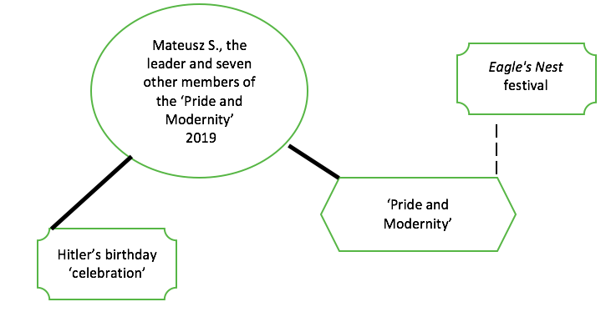

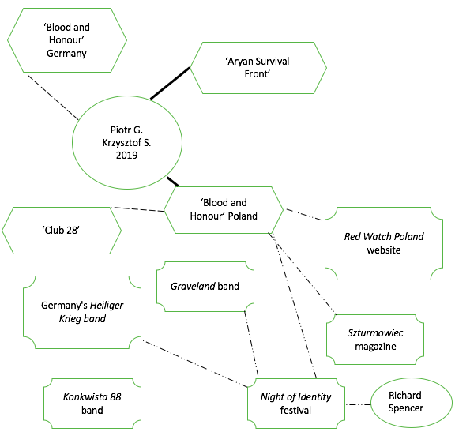

ANTI-MUSLIM AGENT

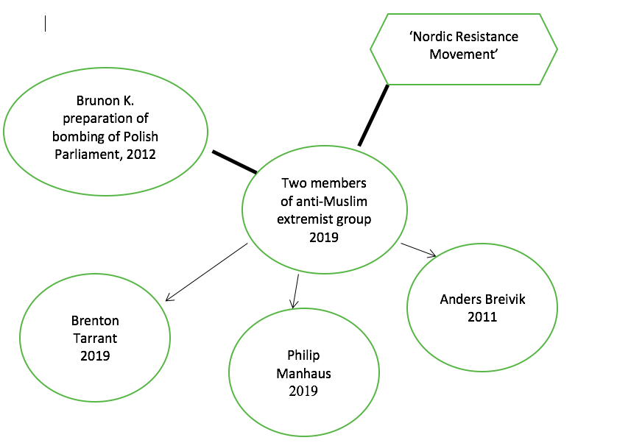

JIHADIST AGENTS

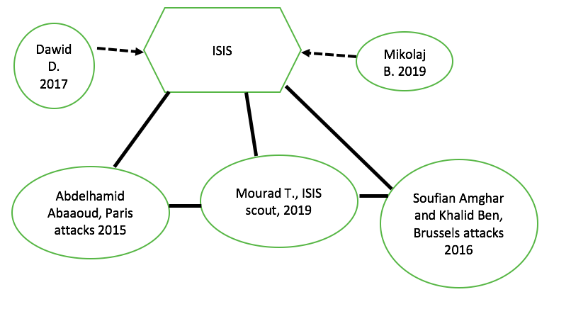

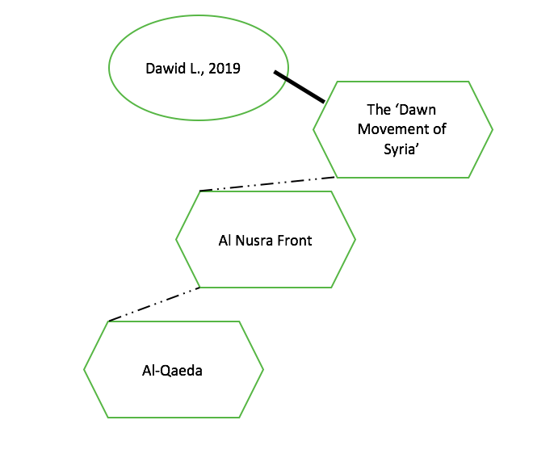

ANARCHIST AGENT

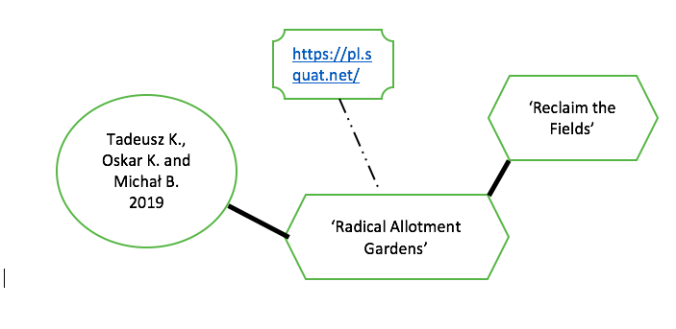

Parties Non-party organizations Main agent of violence Media

Co-membership Collaboration -------- Co-participation
Affiliation Legitimation Recruitment from … to …

Appendix 4. Main de-radicalization programs in Poland

Name | Dates  initiated (and discontinued) | Agents | Approach | Scale | Targets
POWER Increasing the competences of the state security services, employees of public administration and research and development centers and the development of their cooperation in the area of national security | Since 2014 | CPT ABW | Education | National | Practitioners
INDEED Strenghtening comprehensive approach to preventing and couteracting radicalisation based on evidence-based model for evaluation of radicalisation prevention | Unavailable | CPT ABW | Education | National | Practitioners
CHAMPIONs  Co-operative Harmonised Action Model to Stop Polarisation in Our Nations | 2019-2020 | The Institute of Social Safety | Integration of de-radicalization experts through an online platform to solve local issues | National  local | Practitioners
‘Do one brave thing’ | 2019-2021 | The Institute of Social Safety | Civic education | National | People aged 18-30
PRECOBIAS  Prevention of Youth Radicalisation Through Self-Awareness on Cognitive Biases | 2019-2021 | The Institute of Social Safety | Civic education | National | Young people
‘We make young people in Poland immune to radicalization and extremism’ | Unavailable | The Institute of Social Safety | Civic education | National | People aged 18-30
‘Partnership for Active Estates’ | Since 2015 | Ministry of Administration and Digitisation, Voivode | Civic education | Local | Local residents and students
‘Football Fans Together’ | Since 2015 | Ministry of Sport and Tourism | Civic education | Local | Football fans
‘Let’s Kick Racism out of Football Stadiums’ | Since 1996 | ‘Never Again’ Association | Civic education | National | Football fans
‘Etnoliga’ | Unavailable | ‘Foundation for Freedom’ | Integration | Local | Football fans

References and Sources

REFERENCES
Centralne Biuro Śledcze Policji, (2020), Sprawozdanie z działalności Centralnego Biura Śledczego Policji za 2019 rok (w ujęciu statystycznym). Available at: https://cbsp.policja.pl/cbs/do-pobrania/raporty-z-dzialalnosci/9890,Raporty-z-dzialalnosci.html. (Accessed: 1 March 2021)
Chudy, B., (2019) ABW zatrzymała dwie osoby. Planowały zamach na muzułmanów w Polsce. Radio ZET Wiadomosci. Available at: https://wiadomosci.radiozet.pl/Polska/Zamach-zduszony-przez-ABW.-Ekstremisci-zastraszali-muzulmanow. (Accessed: 1 March 2021)
Commissioner for Human Rights, (2019a) „OSIODŁAĆ PEGAZA” Przestrzeganie praw obywatelskich w działalności służb specjalnych – założenia reformy. Available at: https://www.rpo.gov.pl/sites/default/files/OSIOD%C5%81A%C4%86%20PEGAZA%20-%20jak%20powinien%20wygl%C4%85da%C4%87%20nadz%C3%B3r%20nad%20s%C5%82u%C5%BCbami.%20Raport%20ekspert%C3%B3w.pdf. (Accessed: 1 March 2021)
Commissioner for Human Rights, (2019b), 30 przykładów spraw "mowy nienawiści", w których działania prokuratury budzą wątpliwości. Available at: https://www.rpo.gov.pl/pl/content/30-przykladow-mowy-nienawisci-w-ktorych-dzialania-prokuratury-budza-watpliwosci-RPO.
Commissioner for Human Rights, (2019c), Przestrzeganie praw obywatelskich w działalności służb specjalnych. Sesja 7 III KPO. Available at: https://www.rpo.gov.pl/pl/content/panel/sesja-7KPO-prawa-obywatelskie-w-dzialalnosci-sluzb-specjalnych. (Accessed: 1 March 2021)
Dobski M. (2017) Janusz Zemke: Coraz więcej władzy oddajemy służbom, Rzeczpospolita.
Doctrine and Training Centre of the Polish Armed Forces (2020), Security Environment out to 2035 – NUP 2X35: The Polish Perspective. Available at: https://www.wojsko-polskie.pl/sgwp/u/40/a2/40a209c0-4ffa-4f2b-923e-4594dafe5877/analiza_srodowiska_bezpieczenstwa_w_perspektywie_2035_roku_-_en.pdf. (Accessed: 1 March 2021)
Duda, M., (2016) Przestępstwa z nienawiści. Studium prawnokarne i kryminologiczne. Praca doktorska wykonana w Katedrze Kryminologii i Polityki Kryminalnej Wydziału Prawa i Administracji Uniwersytetu Warmińsko-Mazurskiego w Olsztynie.
Dudzińska, A., Kotnarowski, M., (2019) Imaginary Muslims: How the Polish right frames Islam. Brookings. Available at: https://www.brookings.edu/research/imaginary-muslims-how-polands-populists-frame-islam/ (Accessed: 1 March 2021)
eKai, (2019), Rzecznik Episkopatu komentuje logo Marszu Niepodległości. Available at: https://www.ekai.pl/rzecznik-episkopatu-komentuje-logo-marszu-niepodleglosci/
European Parliament (2018) Debate with the Prime Minister of Poland, Mateusz Morawiecki, on the Future of Europe. Available at: https://www.europarl.europa.eu/doceo/document/CRE-8-2018-07-04-ITM-004_EN.html. (Accessed: 1 March 2021)
Foley, J., Gyollai, D. and Szalanska, J. (forthcoming, 2021) ‘Revising Humanitarianism and Solidarity: the UK, Poland and Hungary’ in: J. Foley and U. Korkut (eds.) Contesting Cosmopolitan Europe. Amsterdam: Amsterdam University Press.
Górak-Sosnowska, K., Pachocka, M., (2019) Inventing the Muslim Other in Poland (and Why Does it Differ from Western Europe), Project ‘Muslim minorities and the refugee crisis in Europe.’ Available at: http://refeu.eu/wp-content/uploads/2019/09/034_III_15_Gorak_.pdf. (Accessed: 1 March 2021)
Internal Security Agency, (2020) Ochrona Bezpieczeństwa Wewnętrznego Państwa i Obywatela w latach 2015 -2019. Największe Wyzwania.
Ishchenko, V., (2014) Ukraine has ignored the far right for too long – it must wake up to the danger. The Guardian. Available at: https://www.theguardian.com/world/2015/sep/04/ukraine-government-svoboda-clashes-conflict. (Accessed: 1 March 2021)
Jałoszyński, K., (2008) Współczesny wymiar antyterroryzmu, Warszawa: Trio.
Kalisz, P., (2019). Polski sąd łagodny dla członka ISIS. Marokańczyk skazany za związki z terrorystami. NaTemat. Available at: https://natemat.pl/267677,sad-skazal-marokanczyka-na-5-lat-wiezienia-za-przynaleznosc-do-isis. (Accessed: 1 March 2021)
Kęsek, P., (2020) ‘Uprawnienia śledcze Agencji Bezpieczeństwa Wewnętrznego jako instrument w działaniach służących poprawie bezpieczeństwa państwa’, Przegląd Bezpieczeństwa Wewnętrznego, 23(12), pp. 239 – 253.
Malendowicz P., (2016) ‘Marsz Niepodległości, czyli inna Europa jest możliwa,’
Annales Universitat Mariae Curie-Sklodowska Lublin, XXIII.
Ministry of Interior Affairs, (2014) Białystok się Zmienia. Raport Dotyczący Zwalczania Przestępczości Związanej z Dyskryminacją Rasową, Ksenofobią i Nietolerancją na przykładzie działań Policji Podlaskiej.
Ministry of Justice, ‘Informator Statystyczny Wymiaru Sprawiedliwości’. Available at: https://isws.ms.gov.pl/pl/baza-statystyczna/opracowania-wieloletnie/. (Accessed: 1 March 2021)
National Prosecutorial Office, (2018) Wyciąg ze sprawozdania dot. spraw o przestępstwa popełnione z pobudek rasistowskich, antysemickich lub ksenofobicznych prowadzonych w 2017 roku w jednostkach organizacyjnych prokuratury, PK II P 404.4.2016. Available at: https://pk.gov.pl/dzialalnosc/sprawozdania-i-statystyki/wyciag-ze-sprawozdania-dot-spraw-o-przestepstwa-popelnione-z-pobudek-rasistowskich-antysemickich-lub-ksenofobicznych-prowadzonych-w-2017-roku-w-jednostkach-organizacyjnych-prokuratury/. (Accessed: 1 March 2021)
National Security Bureau, (2014) National Security Strategy of the Republic of Poland. Available at: https://www.bbn.gov.pl/ftp/dok/NSS_RP.pdf. (Accessed: 1 March 2021)
Office for State Protection, (2000), Raport Urzędu Ochrony Państwa dotyczący zagrożeń dla bezpieczeństwa państwa w aspekcie wewnętrznym i zewnętrznym oraz ujawnionych w tym zakresie przestępstw w 1999 roku. Available at: http://www.videofact.com/mark/uop/uop1.html. (Accessed: 1 March 2021)
Pawlak, A., (2015) Poseł Jaki ostro o uchodźcach. "To ksenofobiczna propaganda". Available at: https://opole.wyborcza.pl/opole/1,35086,18816662,patryk-jaki-ostro-o-przyjmowaniu-uchodzcow-przez-polske-wideo.html. (Accessed: 1 March 2021)
Polish Press Agency, (2020) Debata TVP: większość kandydatów na prezydenta przeciwko przymusowej relokacji uchodźców. Available at: https://www.wnp.pl/parlamentarny/spoleczenstwo/debata-tvp-wiekszosc-kandydatow-na-prezydenta-przeciwko-przymusowej-relokacji-uchodzcow,80912.html. (Accessed: 1 March 2021)
Public Opinion Research Center, (April 2016), ‘Terrorist threat after Brussels attacks’. Available at: https://www.cbos.pl/SPISKOM.POL/2016/K_065_16.PDF. (Accessed: 1 March 2021)
Public Opinion Research Center, (December 2015), ‘Terrorist threat after Paris attacks’. Available at: https://www.cbos.pl/SPISKOM.POL/2015/K_177_15.PDF. (Accessed: 1 March 2021)
Public Opinion Research Center, (September 2016), ‘Terrorist threat’. Available at: https://www.cbos.pl/SPISKOM.POL/2016/K_127_16.PDF. (Accessed: 1 March 2021)
Rekawek, K., (2015) ‘So, It’s Not the Islamic State after All? The Threat of International Terrorism in Poland,’ The Polish Institute of International Affairs Bulletin, 75 (807).
Rekawek, K., (2017) ‘Referenced but Not Linear? Counterterrorism in Central-Eastern Europe in Theory and in Practice’. East European Politics and Societies and Cultures, 31(1).
Ruta M., (2018), My, nacjonalistki: Mężczyźni stosujący przemoc wobec kobiet. W domu - najczęściej Polacy, na ulicy - imigranci! Wyborcza.Pl. Available at: https://wyborcza.pl/duzyformat/7,127290,23090679,my-nacjonalistki-mezczyzni-stosujacy-przemoc-wobec-kobiet-w.html
Sejm RP, (2019), Wypowiedzi na posiedzeniach Sejmu
Posiedzenie nr 77 w dniu 30-01-2019 (1. dzień obrad). Available at: http://www.sejm.gov.pl/sejm8.nsf/wypowiedz.xsp?posiedzenie=77&dzien=1&wyp=146&view=. (Accessed: 1 March 2021)
Stożek, M. (2016), ‘Poland’ in: A. Peters and I. Ley (eds.) Freedom of Assembly in Europe. Nomos: Hart Publishing.
The Newsmakers. Here’s why Poland takes in millions of migrants... just not Muslim ones. Available at: https://www.youtube.com/watch?v=TYSX2vI7oPk&feature=youtu.be. (Accessed: 1 March 2021)
Zadlo, A., (2019), ‘’Do Syrii nie jeździ się na saksy’. Czy po raz pierwszy polski dżihadysta zostanie skazany za terroryzm? Gazeta. PL. Available at: https://weekend.gazeta.pl/weekend/1,177333,25125816,do-syrii-nie-jezdzi-sie-na-saksy-czy-po-raz-pierwszy-polski.html. (Accessed: 1 March 2021)

LEGAL SOURCES

Ustawa z dnia 10 czerwca 2016 r. o działaniach antyterrorystycznych (Dz. U. z 2016 r. poz. 904 ze zm.).
Ustawa z dnia 24 maja 2002 r. o Agencji Bezpieczeństwa Wewnętrznego oraz Agencji Wywiadu (Dz. U. z 2010 r. Nr 29, poz. 154 ze zm.).
Ustawa z dnia 6 czerwca 1997 r. Kodeks karny (Dz. U. z 1997 Nr 88, poz. 553 ze zm.).
Ustawa z dnia 6 czerwca 1997 r. Kodeks postępowania karnego (Dz.U. z 1997 Nr 88, poz. 555 ze zm.).

Author’s correspondence with the Ministry of Justice, 21.01.2021.
Statistics received from the Internal Security Agency on 29.01.2021, unpublished.
Author’s correspondence with the Internal Security Agency, 29.01.2021.
The slogans were collected based on Malendowicz (2016) and for the more recent marches newspaper articles were used.
Majority of legal provisions this the act could be classified under would require a ‘dolus directus’ (direct intent) to be tried as a crime.

